The Decomposition of Gender Inequality in Measurement Error and Agricultural Technology Adoption
Jing Yi, Jeisson Prieto, Elisabeth Garner, and Hale Tufan

AffiliationsAbstract
Closing the gender technology gap in agriculture underlies equitable agricultural development interventions. Understanding the nuances of gender disparities in technology adoption is, therefore, pivotal for effective agricultural policy formulation. This study leverages a comprehensive intra-household spousal dataset to analyze the systematic relationship between measurement error and gender in the agricultural sector. We developed a theoretical model to illustrate the impact of systematic measurement error on sex-disaggregated analysis of crop varietal adoption. Our empirical analysis then revealed the presence of non-classical measurement errors related to gender.
Additionally, we employ a decomposition analysis of plot-level improved cassava variety adoption data, providing an in-depth examination of gender inequality in agricultural technology adoption. Significantly, we identify statistically substantial false negative varietal adoption values predominantly linked to female farmers who are not household heads. Our findings support the need for more intersectional and intrahousehold analyses to understand women’s asset ownership and decisions around agricultural technology adoption, leading to more evidence-informed and impactful policy interventions for equitable agricultural development.
Keywords

Introduction
Agricultural development and economic growth in sub-Saharan Africa rest on agricultural productivity, yet the gender productivity gap remains pervasive and persistent (World Bank, 2014). The consequences of gender inequalities are far-reaching, affecting not only productivity but also income, poverty levels, and even undernutrition (Amber, Julia, and Anges, 2010). Agricultural research for development is lauded as a highly effective use of public funding to enhance agricultural productivity, albeit with a large amount of heterogeneity in outcomes (Maredia and Anthony, 2010). Improved crop varieties that exhibit favorable characteristics are a key category of agricultural technology designed to improve the efficiency of agricultural production (Ruzzante et al., 2021). Ample evidence shows, however, that agricultural technology adoption is not gender-neutral. To the contrary, gender and social differences shape technology adoption (Doss and Morris, 2000; Peterman et al., 2014). This is important, as enhancing women’s ownership and control over assets, such as improved agricultural technologies, contributes to positive development outcomes at the household and individual levels (Johnson et al., 2016). Understanding the nuances of gender disparities in technology adoption is, therefore, pivotal for effective agricultural policy formulation.
Gender analysis based on sex-disaggregated data from individuals helps researchers and policymakers unpack who benefits from agricultural development interventions (Doss and Kieran, 2013). Improvements in data collection practices have helped to understand women’s asset ownership and decision-making and have also increased the visibility of women and their experiences in agricultural research for development (Doss, 2021). However, most sex-disaggregated datasets remain largely linked to the position of the household head. Headship does not always reflect decision-making rights nor the experiences of women in partnership with male household heads (Peterman et al., 2014; Deere et al., 2010). Further, shifting from a more unitary household model to a collective one focused on the experiences of individuals within it may miss out on key dynamics where household members jointly control resources (Doss and Quisumbing, 2020). Interviewing single individuals within households can, therefore, lead to incorrect conclusions about the household dynamics (Fisher et al., 2010; Twyman et al., 2015).
Interviewing multiple respondents in household surveys provides a richer and more nuanced understanding of what happens within these households (Doss, 2021). Recent work on spousal intrahousehold datasets reveals interesting insights on information asymmetries that shape spousal concordance on ownership and decision-making in Nepal (Ambler et al., 2021); principal residence valuation in India (Doss et al., 2018); and perceptions of decision-making in agriculture (Twyman et al., 2015; Anderson et al., 2017). Intrahousehold studies on technology adoption offer insight into how household members make decisions on adoption and what affects these decisions. Recent studies have shown, for example, how agricultural adoption and productivity differences between female and male plot managers are explained mainly by structural effects (Tufa et al., 2022). Fisher and Kandiwa (2014) reveal significantly different adoption rates of improved maize varieties between women who are heads of households and women who are wives of male household heads. Further, the results of increasingly nuanced studies reflect the call for more intersectional analyses in agricultural research (Tavenner et al., 2022). For example, status within the household, conferred by gender, marital status, generation, and education, is linked to the adaption of improved sorghum varieties (Smale et al., 2018).
Despite the substantial body of literature dedicated to exploring gender inequality in technology adoption within agriculture, two fundamental issues persist. First, emerging studies have shed light on the presence of measurement errors and misclassifications in self-reported data (Wossen et al., 2019; Aba et al., 2019 & 2023). This raises a pivotal question: if gender inequality in technology adoption is driven by inequality in knowledge resources and assets, could systematic measurement errors be linked to gender and further bias our understanding of technology adoption? Second, the gender inequality observed in technology adoption may be a complex interplay of multiple factors, requiring more unpacking into endowment or coefficient effects to better explain adoption rates and patterns. Given that many genders in technology adoption analyses have employed a binary response model and used a gender dummy variable to capture differences in coefficients, there is potential for methodological enhancements that could disentangle the endowment, coefficient, and interaction effects. Here, we present a comprehensive intra-household spousal dataset to analyze the systematic relationship between measurement error and gender in the agricultural sector. Addressing these questions is pivotal not only for advancing our comprehension of gender disparities in technology adoption within agriculture but also for refining the methodologies employed in agricultural technology adoption gender gap analyses, thus facilitating more nuanced and accurate policy formulation in this critical domain. This is the first study on gender endogenous measurement error and its impact on regression analysis on agricultural technology adoption. This is also the first study analyzing the intrahousehold endowment, coefficient, and interaction effects in gender inequality in technology adoption in agriculture. Moreover, this study employed an innovative approach by harnessing pre-existing datasets from the IITA data repository, originally collected through the Cassava Monitoring Survey in Nigeria. These datasets were seamlessly integrated using a custom-developed data synthesizing algorithm. This novel methodology facilitated the creation of a distinctive intrahousehold dataset, encompassing self-reported adoption of improved cassava varieties (ICV) and DNA fingerprinting test results, without the need for costly field experiments and surveys.

Data
This study is based on Nigeria's intrahousehold cassava monitoring survey (CMS). Cassava (Manihot esculenta) is a vital staple crop, serving as the primary source of calories for approximately 500 million individuals worldwide. Its capacity to thrive with minimal external inputs, particularly in the face of environmental stressors such as drought (EL-Sharkawy, 2003), makes it an essential component of food security and resilience strategies (Montagnac, Davis, and Tanumihardjo, 2009). In Nigeria, cassava cultivation is predominantly carried out by smallholder farmers, both men and women, typically managing land parcels ranging from 1 to 5 hectares (Joyce Ahmadu and P. O. Idisi, 2014). It is pivotal in the country's food economy, ranking as the primary source of carbohydrates after maize and rice (Udensi E Udensi et al., 2011). Given its paramount significance, extensive efforts have been devoted to enhancing cassava production through global, regional, and national crop improvement initiatives, leading to the development and adoption of new cassava varieties (Tahirou Abdoulaye et al., 2014). Prior studies on cassava adoption in Nigeria offer a mixed picture of sex-disaggregated data collection, sample sizes, and gender-related results (Table 1).
Table 1. Sampling and sex-disaggregation of previous studies of improved cassava-related technology adoption in Nigeria (non-systematic review)
Author | Sample Size | Sample frame | Sex-Disaggregation | Gender-Related Results
(Awotide et al. 2014) | 841 HH | Household | - | FHHs more likely to adopt
(Apu and Nwachukwu 2011) | 150 S | Farm families | - | -
(Awotide et al. 2014) | 952 S | Household heads | 89% male  11% female  89% married | Gender not significant
(Agwu, Ekwueme, and Anyanwu 2008) | 135 F | - | 81.5% male  18.5% female  73.3% married | -
(Nwakor et al. 2011) | 150 F | Registered farmers | 45.3% male  54.7% female  70.7% married | Women more likely to adopt
(Obisesan 2014) | 482 HH | Household | 76.23% male  23.8% female | Men more likely to adopt
(Udensi et al. 2011) | 510 F | Community list of Farmers | 43.5% male  56.5% female  78.8% married | Gender not significant in  ICV adoption
(Assfaw Wossen et al. 2017) | 2500 HH | Household heads | - | Men are more likely to adopt. ICV except when adoption is measured by DNA fingerprinting

The analysis conducted herein is based on a subset of data collected through the Cassava Monitoring Survey in Nigeria. This survey underwent rigorous ethical review concerning human subject participation (IRB) and was subsequently published by the International Institute of Tropical Agriculture (IITA) (Wossen et al., 2017). The dataset encompasses 16 states, each contributing at least 80% of the total cassava production. These states constitute the enumeration areas (EAs) distributed across four regions: Southwest, Southeast, South-South, and North.
To create a representative sample, sample frames were established for all households engaged in cassava cultivation in the targeted states. Subsequently, a minimum of 50 cassava-growing households were selected per state, resulting in a sample size of 125 EAs. Within each enumeration area, interviews were conducted with five household heads and two spouses, amounting to 625 households in each region. Consequently, a total of 2,500 randomly selected cassava-growing households were interviewed across the major cassava-growing states in Nigeria's four geopolitical regions. These states collectively account for over 80% of the annual total cassava production.
From the overall survey dataset, interviews were conducted with both the designated household head and an additional household member. This process yielded a subset of 758 households. However, for inclusion in this analysis, households had to meet specific criteria: the recorded relationship to the household head had to be self or spouse, marital status had to be married, and both members needed to report living with their spouse. As a result of these criteria, 29 households were excluded, leaving a final sample of 729 households, consisting of 1,458 men and women (Table 2)
Table 2. Summary statistics for the Household Cassava Dataset
Category | Variable | Male |  | Female
 |  | N | % | N | %
Marital Status | Married, living with spouse/s | 729 | 100.00% | 729 | 100.00%
Relationship to Household | Head | 726 | 99.59% | 13 | 1.80%
 | Spouse | 3 | 0.41% | 716 | 98.20%
Main Occupation | Farmer (crop and livestock) | 588 | 80.70% | 490 | 67.20%
 | Self-employed off farm | 81 | 11.10% | 160 | 21.90%
 | Other | 60 | 8.20% | 79 | 10.90%
Zone | 1 | 186 | 25.50% | 186 | 25.50%
 | 2 | 238 | 32.60% | 238 | 32.60%
 | 3 | 165 | 22.60% | 165 | 22.60%
 | 4 | 140 | 19.20% | 140 | 19.20%

It is important to note that the terminology used intentionally employs "husband" and "wife" rather than "household head" and "spouse." Within this analysis, there are 13 instances of women as household heads and three cases where men are identified as spouses. Among these responses, one household's wife responded as the household head, and the husband responded as the spouse. In the remaining 12 households, both respondents identified themselves as the household head, while two households featured both participants identifying as spouses.

Methodology
In this section, we initially discuss the impact of measurement errors in binary response models, followed by the introduction of the Oaxaca decomposition method to breakdown the compound gender effects.

1. The impact of measurement error in binary response model
Let $Y_{i}$ represents the outcome variable of interest, which is adoption of improved cassava varieties (ICV). Assuming that the probability of adopting ICV is contingent on resources and socio-economic variables, we can express this relationship as follows:
Where is independently from a standard normal distribution, and is the K-by-1 coefficient vector of interest. The observable outcomes of the binary choice are represented by binary indicator variable:
Where F denotes the c.d.f function. Then the probabilities of false positives and false negatives are:
As Hausman, Abrevaya, and Scott-Morton (1998) demonstrated, the estimated marginal effects based on the observed data are:
When there is no misclassification, , and eq. (4) is unbiased:
On the other hand, when the data contains false negatives (), given the assumption that the self-reported adoption data is independent of the covariates X:
Then the estimated marginal effects are proportional to the true marginal effects:
where when there is false negatives. Thus, eq. (6) reveals that the estimates are attenuated when the self-reported technology adoption data contains false negatives. The estimates are smaller in absolute value, but retain the correct signs.

2. The Blinder-Oaxaca decomposition method
In this section, we discuss another methodological contribution of this study. As summarized in Peterman et al. (2014), most technology adoption analyses have relied on bivariate response models. However, such models, often employing a gender dummy variable to test gender differences, do not provide a nuanced breakdown of gender inequality into its constituent components. For instance, men and women may exhibit disparities in access to cooperative resources and extension services, and these differences may have varying impacts on each gender group (e.g., Jagger and Pender, 2006; Katungi, Edmeades, and Smale, 2008). A simple binary variable fails to dissect these variations between groups.
In this section, we introduce the Blinder-Oaxaca decomposition method which disentangles group differences into components. The approach with binary dependent variable was originally developed by Fairlie (2005). It is easy to apply based on the binary response modeling results to decompose inter-group differences (Fitzenberger, Kohn, and Wang, 2006). In this study, we label the two gender groups as Group F and Group M for female and male farmers. The mean outcome difference to be explained (). Following eq. (2), the decomposition of a binary response model is (Oaxaca and Ransom, 1994):
Where is a weighted average of the coefficient vector of and . The eq. (8) can be written as:
Where is a weighting matrix and I is an identity matrix.
Where represents a conditional expectation, and is the conditional expectation of evaluated at the parameter vector . The estimations of the conditional expectation in probit models follow the specifications proposed by Fitzenberger, Kohn, and Wang (2006). Then, as Daymont and Andrisani (1984) proposed, we can simplify the eq. (10) to

In eq. (11), the endowments term represents the contribution of differences in explanatory variables across groups, and the coefficients term is the part that is due to group differences in the coefficients. The interaction term accounts for the fact that cross-group differences in explanatory variables and coefficients can occur at the same time.

Results
In this section, we first show the misclassification problem after discussing the identification of systematic measurement error, followed by the gender decomposition results.

1. The misclassification problem
We establish a correlation between relationships and covariates through intrahousehold data synthesis, showcasing explicit misclassification issues. Figure 1 depicts the link between self-reported technology adoption (ICV) and the female percentage within the dataset, offering insights into adoption rates across 500 iterations with 728 households. As the female representation increases, self-reported adoption diminishes. Additionally, Figure 2 simulates ICV adoption reported by husbands and wives across 500 iterations, showcasing how the female response rate affects reported adoption rates within 729 households. This simulation suggests that a higher female participation rate correlates with an increased likelihood of encountering false negatives in reported adoption rates, aligning with DNA fingerprinting "true" adoption rate of 64% among the households. These visualizations highlight the correlation between female participation and inaccuracies in reported technology adoption.

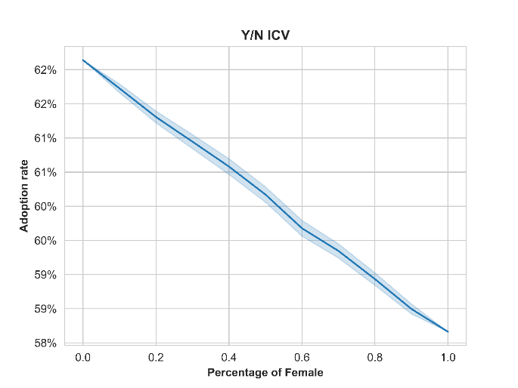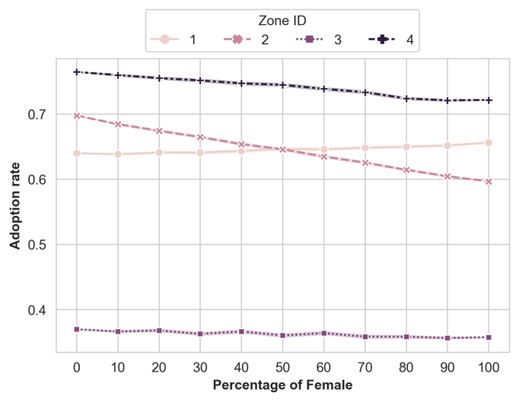

Figure 1. The self-reported ICV adoption (500 iterations of each percentage)
Note: 500 iterations of each percentage of female.
Figure 2 replicates the figure by only having five iterations, highlighting the variation in collected data. The right panel in Figure 2 shows the change in adoption rates of each zone as the proportion of female farmers was surveyed. The rank of the adoption rate of zones 1 and 3 was overturned as the proportion of women changed.
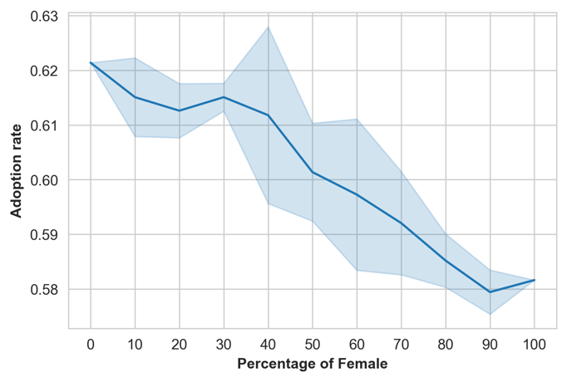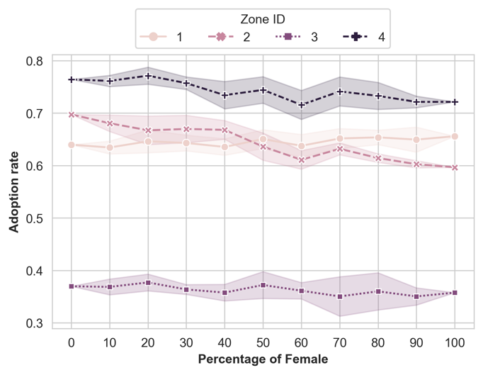

Figure 2. The self-reported ICV adoption (5 iterations of each percentage)
Note: 5 iterations of each percentage of females.

In general, Figures 1 and 2 also reveal some interesting zone-specific patterns. For example, Zone 4 has the highest adoption rate across all percentages of females, while Zone 3 has the lowest adoption rate. This suggests that Zone 4 is more receptive to new technologies and innovations, while Zone 3 is more resistant. Additionally, the rate at which the adoption rate increases with the percentage of females varies across zones. For example, in Zone 1, it is the only zone that shows an increment in the adoption rate with the percentage of females, while in the other Zones, the adoption rate decreases slowly. This suggests that there may be different factors driving adoption in different zones.

2. Systematic measurement error
The mean differences by gender presented in Table 3 show that the mean of the Y/N ICV variable is higher for husbands than for wives in three of the four zones (Zone 2, 3, and 4). This further confirms that husbands are likelier to report that their household has adopted the new agricultural technology than wives. Overall, the table suggests that there are non-classical measurement errors in technology adoption reporting, with women being more likely to underreport their adoption than men. This is likely due to several factors, such as gendered social norms and biases, as well as a lack of access to information and resources.
Table 3. Descriptive statistics and results from the test and mean differences by gender
 | DNA-fingerprint | Husbands | Wives | Test statistics
Variable description. | [1] | [2] | [3] | [1]-[2] | [1]-[3] | [2]-[3]
Dependent variables.
Y/N ICV.
All observations. | 0.645 | 0.621 | 0.582 | 0.977 | 2.598*** | 2.224**
Zone 1. | 0.597 | 0.64 | 0.656 | -0.905 | -1.209 | -0.419
Zone 2. | 0.693 | 0.697 | 0.597 | -0.094 | 2.142** | 2.755***
Zone 3. | 0.503 | 0.37 | 0.358 | 2.639*** | 2.810*** | 0.47
Zone 4. | 0.793 | 0.764 | 0.721 | 0.631 | 1.59 | 1.227
All observations. | 1.775 | 1.512 | 1.39 | 4.355*** | 4.921*** | 1.828*
Zone 1. | 1.586 | 1.204 | 1.333 | 4.342*** | 1.961* | -1.164
Zone 2. | 1.66 | 1.773 | 1.555 | -1.375 | 0.722 | 1.690*
Zone 3. | 1.909 | 1.267 | 1.055 | 3.481*** | 4.400*** | 1.29
Zone 4. | 2.064 | 1.764 | 1.579 | 2.379** | 3.334*** | 1.622
Independent variables
Managed plots
Male Managed. |  | 0.978 | 0.621 |  |  | 6.026***
Female Managed. |  | 0.095 | 0.276 |  |  | -5.875***
Joint Managed. |  | 1.414 | 1.656 |  |  | -3.276***
Household Plots. |  | 2.506 | 2.565 |  |  | -1.181
Cassava Plot Size (K). |  | 12.683 | 7.68 |  |  | 6.487***
Income from Cassava (\%). |  | 3.133 | 3.173 |  |  | -0.873
Membership of a coop
Household. |  | 0.262 | 0.296 |  |  | -1.699*
Men Only. |  | 0.067 | 0.091 |  |  | -1.847*
Women Only. |  | 0.016 | 0.029 |  |  | -1.734*
Joint Coop. |  | 0.176 | 0.178 |  |  | -0.147
Credit Access
Household. |  | 0.451 | 0.379 |  |  | 3.193***
Male Only. |  | 0.112 | 0.043 |  |  | 5.163***
Female Only. |  | 0.018 | 0.033 |  |  | -1.862*
Joint Credit. |  | 0.321 | 0.303 |  |  | 0.804
Processing Access
Male Processing Access. |  | 0.232 | 0.254 |  |  | -0.665
Female Processing Access. |  | 0.743 | 1.126 |  |  | -6.269***
Joint Processing Access. |  | 1.753 | 1.136 |  |  | 8.775***
Household Asset Value (M)
Male Owned. |  | 108.519 | 5.323 |  |  | 3.939***
Female Owned. |  | 4.529 | 1.803 |  |  | 1.057
Total Household. |  | 113.06 | 5.504 |  |  | 3.965***
Production Asset Value (K)
Male Value. |  | 1484.778 | 359.289 |  |  | 0.808
Female Value. |  | 6.732 | 8.178 |  |  | -0.618
Total Value. |  | 1493.651 | 260.541 |  |  | 0.888
Household attributes
Age. |  | 50.543 | 40.435 |  |  | 28.879***
Education. |  | 9.342 | 8.029 |  |  | 6.858***
Main occupation. |  | 1.148 | 2.045 |  |  | -7.259***
Contribution to farm work (\%). |  | 80.206 | 70.089 |  |  | 8.646***
Men In House. |  | 2.314 | 2.1 |  |  | 4.918***
Women In House. |  | 2.23 | 2.169 |  |  | 1.491
Kids. |  | 2.763 | 2.599 |  |  | 2.135**
Notes: Robust standard errors in parentheses ***p < 0.01, **p < 0.05, *p < 0.1.
Figure 3 shows the kernel density plot of the household ICV adoption reported by husbands and wives and the results of corresponding DNA fingerprinting tests. Table 4 summarizes the paired t-test for self-reported and DNA fingerprinting tests. The paired t-test was employed to assess the alignment between women's self-reported household ICV adoption and the corresponding DNA fingerprinting test results, with a summary of these results in the table's first row. Similarly, the middle row of the table offers a summary of the test statistics for men, where we compared their self-reported household ICV adoption with the household's DNA fingerprinting data. The last row pertains to a distinct dataset, specifically households where wives self-identified as the household heads. This row investigates the consistency between their self-reported ICV adoption and the household's DNA test results.

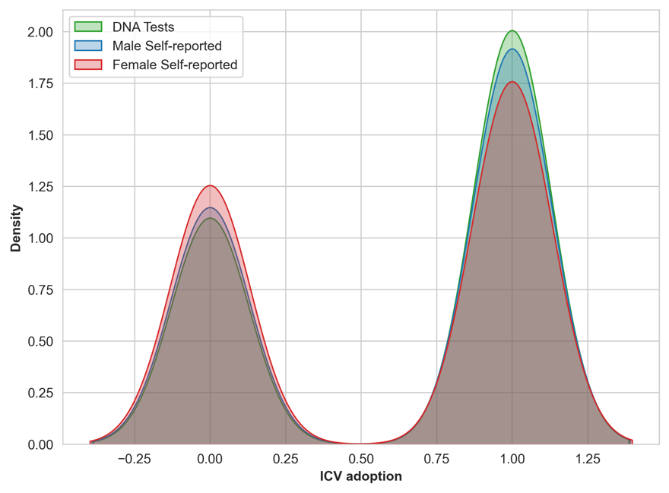

Figure 3. The comparison of the self-reported and DNA fingerprinting data

Table 4. Paired t-test results for self-reported and DNA fingerprinting data
Variable | T-Statistic | P-Value
Female self-reported | -2.508 | 0.012
Male self-reported | -0.870 | 0.384
Female self-reported (Household head) | -0.433 | 0.673
Note: The paired t-test was conducted to compare the self-reported household ICV adoption among women with the corresponding DNA fingerprinting test results. The test results were summarized in the first row. Likewise, the middle row of the table presents a summary of the test statistics for men, where self-reported household ICV adoption was compared to the household's DNA test results. The final row pertains to a distinct dataset, comprising households in which wives identified themselves as the household heads, and it examines the concordance between their self-reported ICV adoption and the household's DNA test results.

For the self-reported adoption of ICV by females, the probability of a negative response (no adoption) is higher compared to the results obtained from DNA testing (Figure 3). The pared t-test also rejected the null hypothesis that there is no difference in the two groups (female self-reported vs DNA testing). Conversely, for male self-reported adoption of ICVs, the paired t-test does not reject the null hypothesis, suggesting no significant difference when compare to the DNA testing results. Both Figure 3 and Table 4 highlight the occurrence of false negatives in the female self-reported data.

To explicitly demonstrate the biased regression results, we separated the intro-household dataset into the female and male datasets to test the structural differences between the two datasets. The regression results show that there is a positive relationship between coop members and household ICV adoption reported by husbands; however, no statistically significant relationship was found using women’s self-reported dataset. We can expect that when the two genders’ self-reported data were combined, the regression results would be attenuated due to the low response from females.

As outlined in eq. (7), there is a potential for attenuation in the estimates due to the presence of false negatives. Table 5 summarizes the regression results derived from the probit model, which analyzes male and female self-reported data independently. It is observed that the estimates obtained from the female self-reported data consistently exhibit smaller magnitudes in comparison to those derived from the male cohort.

Table 5. Regression results (Probit model)
 | Male |  | Female
 | Self-reported | DNA | Self-reported | DNA
Joint Coop | 0.199*** | -0.099 | 0.018 | -0.056
 | (0.032) | (0.085) | (0.088) | (0.057)
Household Credit | -0.056 | -0.015 | -0.003 | 0.104
 | (0.067) | (0.122) | (0.100) | (0.141)
Extension Access | 0.417*** | 0.244*** | 0.083 | -0.106
 | (0.062) | (0.094) | (0.116) | (0.139)
Consumption (%) | -0.002 | -0.001 | -0.004*** | 0.003
 | (0.004) | (0.007) | (0.001) | (0.002)
Zone 1 | -0.099*** | 0.182*** | -0.245*** | -0.164***
 | (0.022) | (0.039) | (0.048) | (0.049)
Zone 3 | -0.637*** | -0.622*** | -0.478*** | -0.579***
 | (0.028) | (0.098) | (0.023) | (0.033)
Zone 4 | 0.339*** | 0.313*** | 0.344*** | 0.321***
 | (0.068) | (0.102) | (0.061) | (0.052)
Age | 0.003 | 0.003 | 0.008*** | 0.015***
 | (0.005) | (0.009) | (0.003) | (0.003)
Education | -0.010* | 0.008 | 0.002 | 0.012
 | (0.005) | (0.021) | (0.023) | (0.017)
Household size | 0.069*** | 0.050** | -0.004 | -0.014
 | (0.014) | (0.022) | (0.013) | (0.034)
Main occupation: Salaried employment | -0.143 | -0.083 | 0.292** | -0.006
 | (0.251) | (0.300) | (0.143) | (0.316)
const | -0.052 | -0.158 | 0.145 | -0.219
 | (0.147) | (0.407) | (0.352) | (0.192)
N | 729 | 729 | 729 | 729
Notes:
1. The dependent variables are the self-reported ICV adoption and DNA test. The Self-report column summarizes the results based on the male and female self-reported data, respectively. On the other hand, the DNA test summarizes the results of when the DNA test is assumed as the dependent variable for the male and female self-reported data.
2. (*, **, ***) indicate statistical significance at the 10%, 5%, and 1% level.
3. Standard errors are clustered by zone.

It is noteworthy that, despite the statistical discrepancy between the female self-reported data and the DNA testing results (referenced in Table 3), the test results positioned a consistency between the self-reported data from females who identified themselves as household heads and the DNA testing results. An additional observation is that only about 2% of females identified themselves as household heads in the dataset. Notably, household heads of both genders exhibited accurate classifications in their ICV adoption. This pattern implies that male farmers are predominantly the decision-makers in these households. Consequently, women farmers who do not assume the role of household head may have limited insight into household affairs. On the contrary, wives who consider themselves household heads appear to possess more comprehensive knowledge and engage more actively in household decision-making processes.

3. Gender disparities in technology adoption
Based on the findings discussed above, as women farmers may not be aware of the correct technology adoption information of the households, for this decomposition analysis, we opt for plot-level data with the assumption that women farmers serve as the household head roles for the plots that they separately managed. The dependent variable in the decomposition analysis is the ICV adoption in the plots that are managed by husbands and wives separately. The DNA fingerprinting test results are not applied in this gender decomposition analysis as the DNA tests assessed household-level adoption, which does not distinguish between male and female behaviors. Since merely 2% of females in the sample self-identified as household heads, reliance on household heads would lead to a gender imbalance in the dataset. To address the issue of measurement error and to analyze gender differences, our focus shifts to plot-level data in this following empirical analysis of gender inequality in technology adoption (see Figure 4). This approach allows for a distinct comparison of plots managed by females versus those managed by males, thereby offering a more nuanced understanding of gender-specific adoption patterns.
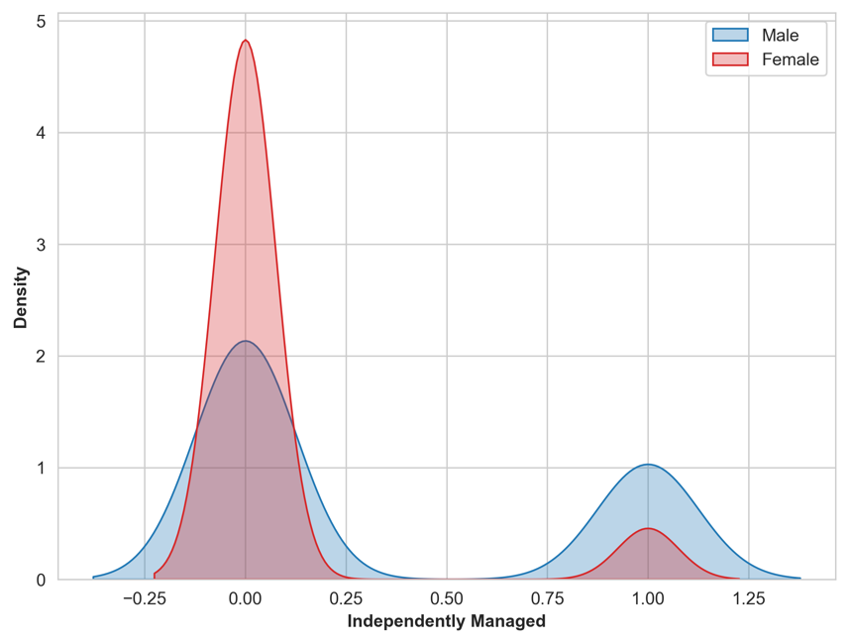

Figure 4. The comparison of the self-reported ICV adoption managed by each gender.

Table 6 presents the Blinder-Oaxaca decomposition results of gender inequality in ICV adoption. The adoption rate of ICV in separately managed plots is 0.09 and 0.32 for the female and male groups, respectively, indicating a notable difference of 0.48 between the two groups. The decomposition results suggest that the gender inequality was primarily attributed to the differences in coefficients, as the overall coefficient effect is 0.72, the endowment effect is -0.05, and the interaction effect is 0.12 (detailed in Table 5).

Table 6. The Blinder-Oaxaca decomposition results in gender inequality
 | Female | Male | Gap
Mean by gender | 0.086 | 0.324 | -0.238
 | Endowments | Coefficients | Interaction
Aggregate decomposition | -0.051 | -0.723 *** | -0.122
 | (0.064) | (0.126) | (0.101)
Share of the gap | 5.69\% | 80.69\% | 13.62\%
Detailed decomposition
constant | -0.000 | -1.235 *** | -0.000
 | (0.000) | (0.472) | (0.000)
Coop Member | 0.007 | -0.136 ** | -0.018
 | (0.007) | (0.055) | (0.016)
Household Credit | 0.009 | 0.051 | -0.008
 | (0.010) | (0.089) | (0.015)
Extension Access | -0.062 *** | -0.188 ** | 0.068 **
 | (0.020) | (0.088) | (0.033)
Consumption (%) | 0.006 | 0.096 | -0.003
 | (0.007) | (0.205) | (0.008)
Zone 1 | -0.000 | -0.056 | 0.000
 | (0.004) | (0.044) | (0.007)
Zone 3 | 0.001 | 0.007 | -0.000
 | (0.010) | (0.048) | (0.005)
Zone 4 | -0.002 | 0.104 *** | 0.003
 | (0.007) | (0.036) | (0.012)
Age | 0.020 | 0.746 * | -0.150 *
 | (0.048) | (0.432) | (0.088)
Education | -0.017 | 0.071 | -0.010
 | (0.016) | (0.187) | (0.025)
Household size | -0.013 | -0.037 | 0.002
 | (0.009) | (0.210) | (0.014)
Salaried employment | 0.002 | -0.023 | -0.008
 | (0.006) | (0.036) | (0.014)
(Base) | -0.001 | -0.123 ** | 0.001
 | (0.017) | (0.052) | (0.010)
Notes:
1. The dependent variables are the self-reported ICV plots each gender manages.
2. (*, **, ***) indicate statistical significance at the 10%, 5%, and 1% level.
3. Bootstrap standard errors.

Notably, the breakdown of endowment effects illustrates that female farmers have limited access to extension services compared to male farmers (Table 6). This disparity could stem from potential discrimination by extension services, which are more male-oriented, potentially creating barriers to access or relevance for female farmers. It may be that women farmers are less proactive in seeking out these services. This trend could be linked to their relatively passive role in households where they are not the household heads, further impacting their access to and utilization of these services.

Both cooperative memberships and extension services demonstrate a diminished impact on females compared to males, which implies that the content and delivery of these services might not be tailored to the specific needs and circumstances of women farmers, further diminishing the effectiveness of services. Furthermore, this gender gap in service impact highlights the need for a more inclusive approach in agricultural policy and program design. Policies and interventions that recognize and address these gender-specific barriers can enhance the effectiveness of services for female farmers. Initiatives could include targeted outreach programs, gender-sensitive training materials, and the involvement of women in the planning and implementation of agricultural services. By adopting strategies that are more attuned to the needs of women, there is potential to improve the impact of cooperative memberships and extension services on female farmers and promote greater gender equality in agricultural productivity and development.

Conclusion
This study has made significant contributions in understanding gender disparities in agricultural technology adoption. Our comprehensive analysis, leveraging intra-household datasets from the IITA, has shed light on the systematic relationship between measurement error and gender, marking a pioneering effort in this field. Through the development of a theoretical model and empirical analysis, we have illuminated the nuances of non-classical measurement errors related to gender in agricultural practices.
Our findings reveal a noteworthy gender gap in the adoption of improved cassava varieties, as analyzed through plot-level decomposition. A key discovery of this research is the statistically significant false negatives associated predominantly with women farmers who are not household heads. This indicates a systemic issue where women, especially those not in leadership roles within their households, face obstacles in accessing and adopting agricultural technologies.
The study further identifies a critical disparity in the impact of cooperative memberships and extension services between male and female farmers. Women farmers are shown to have less access to these services, potentially due to a combination of institutional biases and their less proactive role in seeking out these resources. This trend is concerning as it suggests that existing services are not adequately catering to the specific needs of women in agriculture, thereby limiting their effectiveness.

Access to education and extension are important determinants to improved variety adoption (Ruzzante et al., 2021; Acevedo et al., 2020)
The implications of these findings are profound for policy formulation and program design in the agricultural sector. There is an urgent need for policies and interventions that specifically address the unique challenges faced by women farmers. This includes the development of more inclusive and gender-sensitive approaches in the delivery of extension services and cooperative memberships. Engaging women in the planning and implementation phases of these services is crucial. Furthermore, tailored outreach programs and training materials designed to meet the needs of women farmers can play a significant role in closing the gender gap in technology adoption.
In conclusion, our study highlights the necessity of rethinking and restructuring agricultural policies and services with a gender-inclusive lens. By doing so, we can empower women farmers, enhance their decision-making capabilities, and ensure equitable access to agricultural innovations. This not only promotes gender equality but also has the potential to significantly boost agricultural productivity and development.
Using headship as a gender indicator is not necessarily indicative as to who actually makes decisions for agricultural production (Peterman, Behrman, & Quisumbing, 2010); hence, such studies end up dismissing the decision-making role of women within male-headed households and males within female-headed households (Doss, 2015). Women in male-headed households make production decisions often jointly with their spouses (Deere, Alvarado, & Twyman, 2009) while men (e.g., adult sons) in female-headed households also make such decisions (Bourdillon et al., 2002).

The findings show that in the North, women produce 28% less than men after controlling forobserved factors of production, while there are no significant gender differences in the South. In the decomposition results, the structural effect inthe North is larger than the endowment at the mean. Although women in the North have access to less productive resources than men, the resultsindicate that even if given the same level of inputs, significant differences still emerge. However, for the South, the decomposition results show thatthe endowment effect is more important than the structural effect. Access to resources explains most of the gender gap in the South and if womenare given the same level of inputs as men, the gap will be minimal. The difference in the results for the North and South suggests that policy shouldvary by region (Oseni, 2015)

Plot manager vs respondent
Caution from doss on intrahousehold

Funding Acknowledgement:
The authors declare financial support was received for the research, authorship, and/or publication of this article. We acknowledge the support and funding of the CGIAR Excellence in Breeding (EiB) Platform.

References

However, if the condition in eq. (6) does not hold; the estimates (eq. (7)) are misleading (Meyer and Mittag, 2017).
The adoption rate is lower than the household adoption rate because the decomposition analysis only focus on plots managed by either husbands or wives to identify the gender gap in technology adoption. In addition to these separately managed plots, it is important to acknowledge that households also have plots jointly managed by both spouses.

